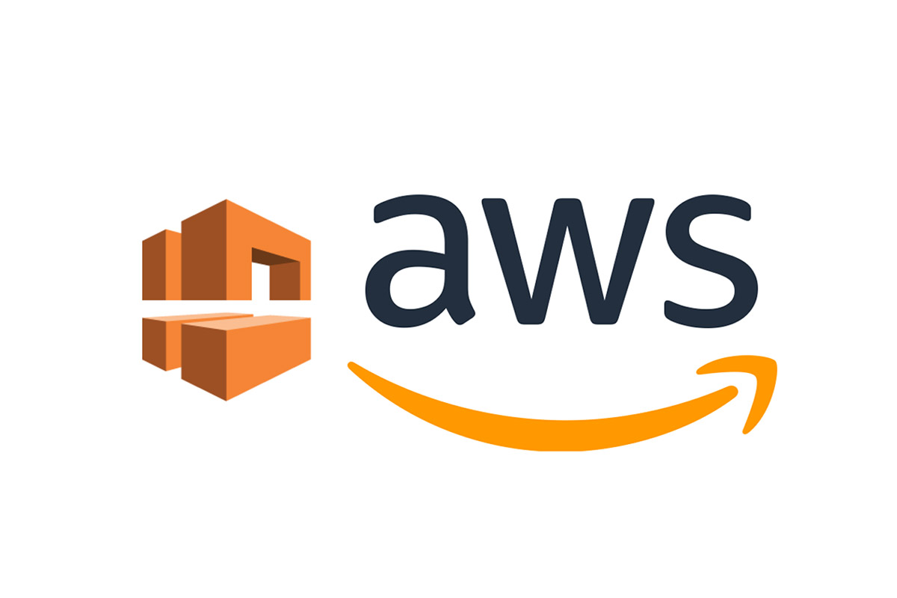

Building a VPC and Launching a Web Server

AWS Lab 2

Evan Choi | Cisco CCNP | 4/24/2022

**Background Information**

Amazon Virtual Private Cloud (VPC) allows you to launch AWS resources into your own virtual network. This virtual network will be similar to a traditional network, but it has the benefits of AWS.

**Configuration Steps**

Opening AWS

1. Click the start lab button until you get the **“Lab status ready”** message



1. Open the AWS Management Console by clicking the AWS button



1. Take note of the region

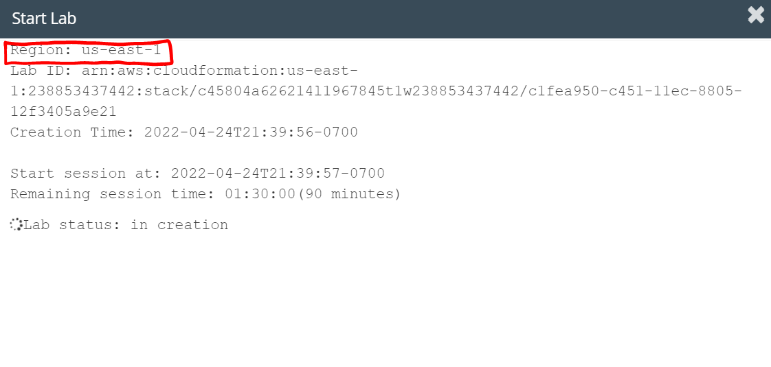

Creating Your VPC

1. On the top left, click the **Services** box, then click the **All services** dropdown and scroll down until you see **VPC**. Click on **VPC.**

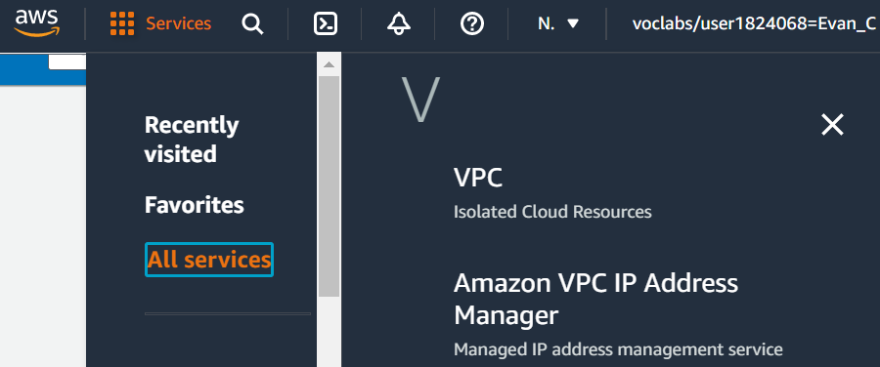

1. Then, click the orange **Launch VPC Wizard** button



1. On the left menu, click **VPC with Public and Private Subnets**
2. Click the blue **Select** button. Configure the following:

**VPC name:** Lab VPC

**Availability Zone:** Select the first Availability Zone in the drop down

**Public subnet name:** Public Subnet 1

**Availability Zone:** Select the first Availability Zone in the drop down

**Private subnet name:** Private Subnet 1

**Elastic IP Allocation ID:** Click the box and select the IP address displayed

It should look something like this:

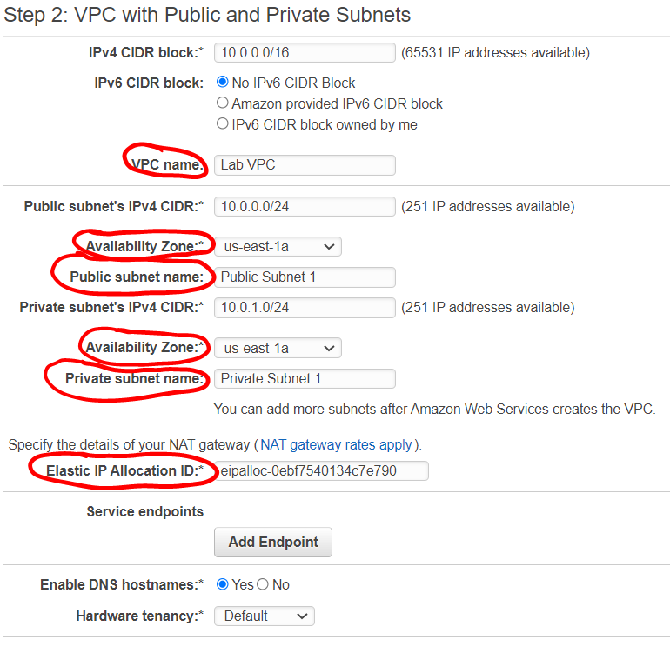

1. Click the blue **Create VPC** button
2. Once this finishes, click the blue **OK** button. VPC Wizard has created a public and private subnet in the same Availability Zone.

The Public Subnet has a CIDR of 10.0.0.0/24 so all its IP addresses start with 10.0.0.x, and the Private Subnet has a CIDR of 10.0.0.1/24 so all its IP addresses start with 10.0.1.x.

Creating Additional Subnets

1. First, we’re going to create the second public subnet. On the left menu, click **Subnets**

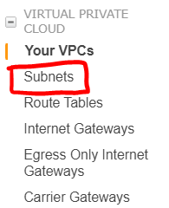

1. Click the orange **Create subnet** button. Configure the following:

**VPC ID:** Lab VPC

**Subnet name:** Public Subnet 2

**Availability Zone:** Select the second Availability Zone in the drop down

**IPv4 CIDR block:** 10.0.2.0/24

It should look something like this:

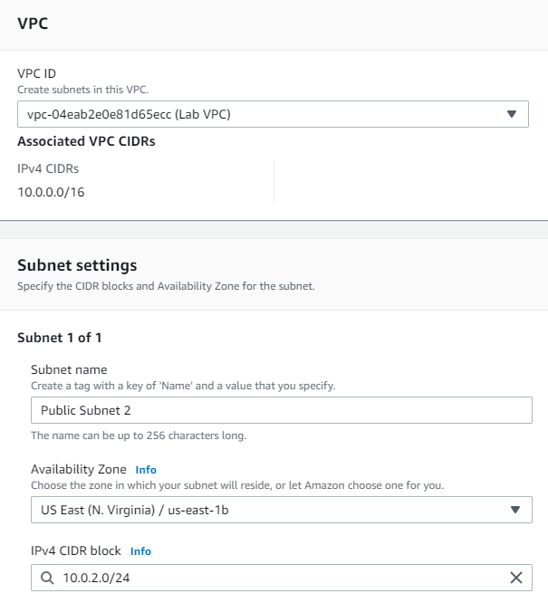

1. Click the orange **Create subnet** button
2. Now, we’re going to create the second public subnet. Click the orange **Create subnet** button. Configure the following:

**VPC ID:** Lab VPC

**Subnet name:** Private Subnet 2

**Availability Zone:** Select the second Availability Zone in the drop down

**IPv4 CIDR block:** 10.0.3.0/24

It should look something like this:

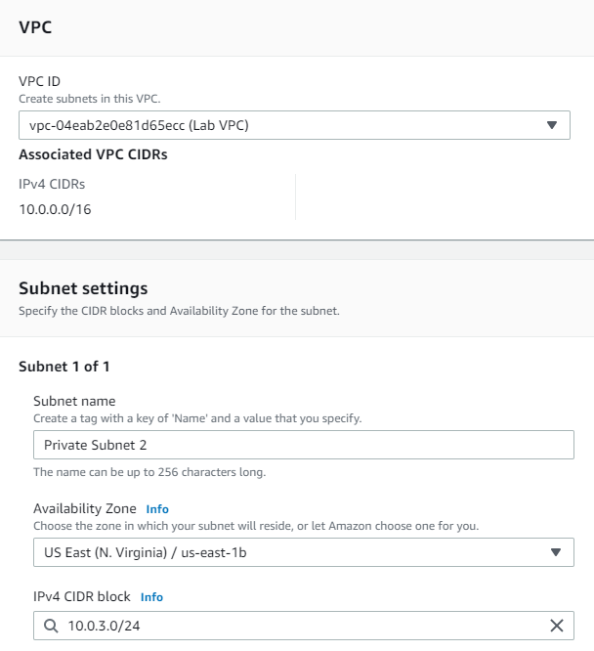

1. Click the orange **Create subnet** button
2. On the left menu, click **Route Tables**

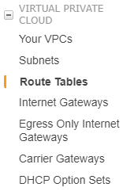

1. Select the route table with a **Yes** under the **Main** column and **LAB VPC** under the **VPC** column. You may need to expand the VPC column to see the name

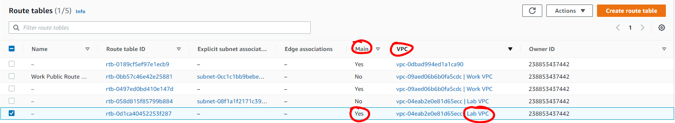

1. Name it **Private Route Table** by hovering over the name column, click the pencil, typing the name, and clicking the orange **Save** button.

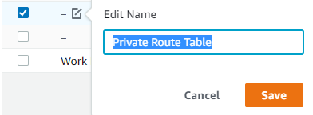

1. Scroll down and click the **Subnet Associations** tab



1. Click the **Edit subnet associations** button
2. Select **Private Subnet 1** and **Private Subnet 2** and click the **Save associations** button

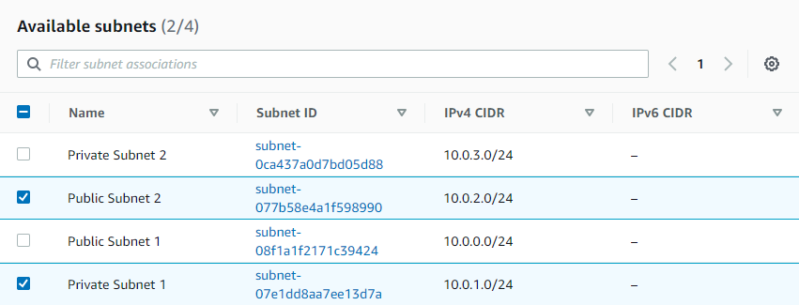

1. Select the route table with a **No** under the **Main** column and **LAB VPC** under the **VPC** column. You may need to expand the VPC column to see the name

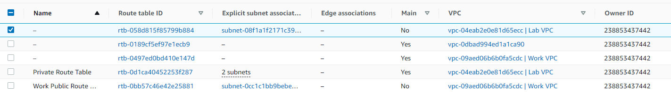

1. Name it **Public Route Table** by hovering over the name column, click the pencil, typing the name, and clicking the orange **Save** button.

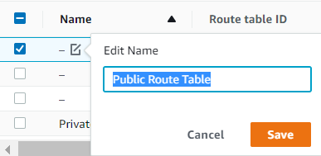

1. Click the **Subnet associations** tab
2. Click the **Edit subnet associations** button
3. Select **Public Subnet 1** and **Public Subnet 2** and click the **Save associations** button

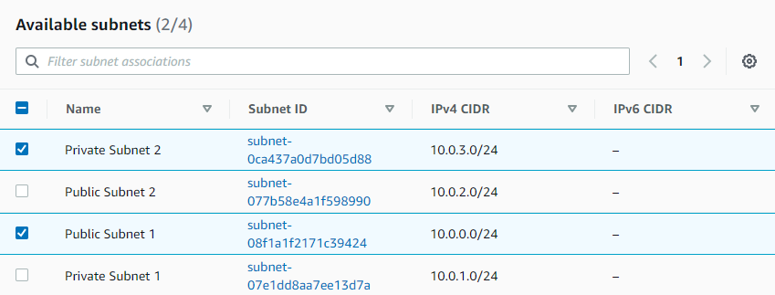

Create a VPC Security Group

1. In the left menu, click **Security Groups**

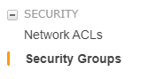

1. Click the orange **Create security group** button and configure the following:

**Security group name:** Web Security Group

**Description:** Enable HTTP access

**VPC:** Lab VPC

It should look something like this:

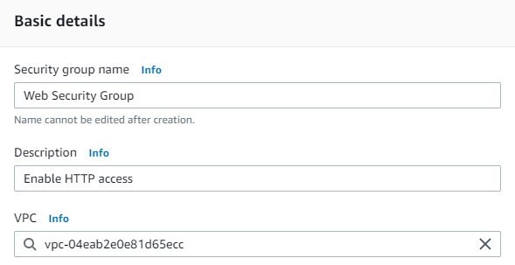

1. Scroll down to the **Inbound rules** section, and click **Add Rule**
2. Configure the following:

**Type:** HTTP

**Source:** Anywhere-IPv4

**Description:** Permit web requests

It should look something like this:

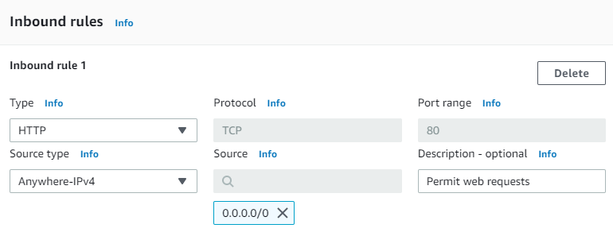

1. Scroll down and click the orange **Create security group** button

Launch a Web Server Instance

1. On the top left, click the **Services** drop down, click **All Services,** and scroll until you see **EC2.** Click **EC2.**

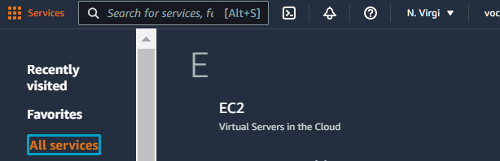

1. Click the orange **Launch Instance** button
2. Name the instance: Web Server 1
3. Keep the AMI the default **Amazon Linux** AMI, and keep the default **Amazon Linux 2 AMI**
4. Keep the Instance type the same **t2.micro**

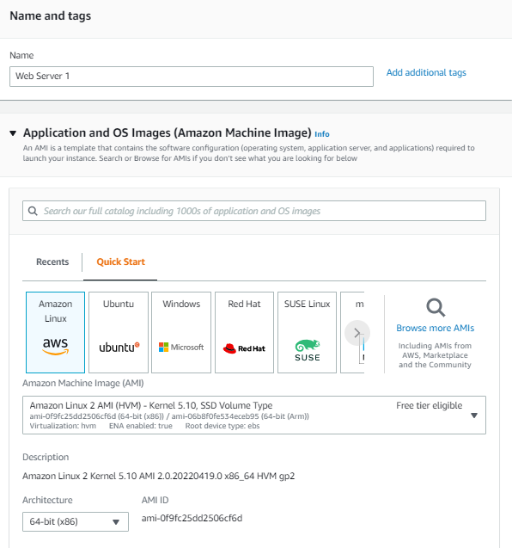

1. Click the **Key pair name** menu and select **vockey**
2. In the Network settings click the **Edit** button and configure the following:

**Network:** Lab VPC

**Subnet:** Public Subnet 2

**Auto-assign public IP:** Enable

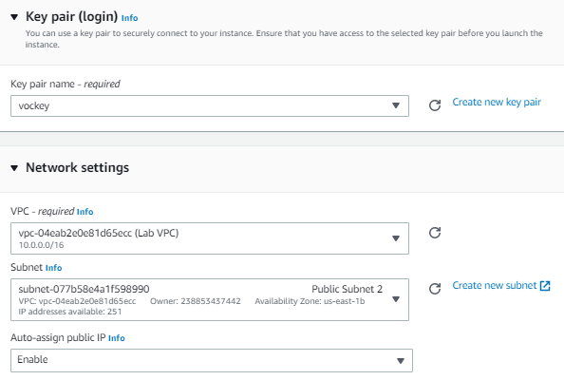

1. Under the Firewall section, choose **Select an existing security group**
2. For **Common security groups,** select **Web Security Group**
3. Keep the default Configure storage settings

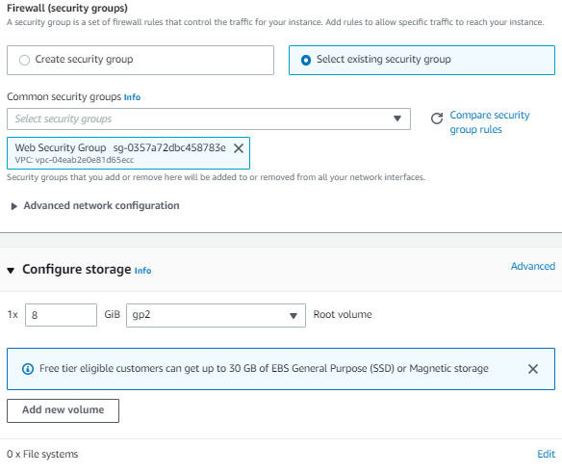

1. Expand the **Advanced details** panel and paste this into the **User data** box:

#!/bin/bash

# Install Apache Web Server and PHP

yum install -y httpd mysql php

# Download Lab files

wget https://aws-tc-largeobjects.s3.us-west-2.amazonaws.com/CUR-TF-100-ACCLFO-2/2-lab2-vpc/s3/lab-app.zip

unzip lab-app.zip -d /var/www/html/

# Turn on web server

chkconfig httpd on

service httpd start

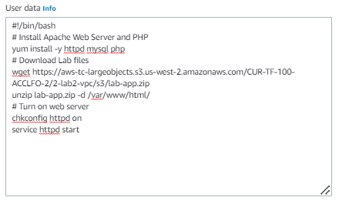

1. Click the orange **Launch instance** button
2. Click the orange **View all instances** button
3. Wait for **Web Server 1** to show 2/2 checks passed under the **Status check** column, then select **Web Server 1**



1. Copy the **Public Ipv4 DNS** value under the **Details** page

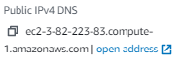

1. Open a new browser and paste the **Public DNS** value**.** A web page with the AWS logo and instance meta-data values should appear

You have finished this lab!

1. Click the **End Lab** button and select the blue **Yes** button.



**Conclusion**

In this lab, using VPC Wizard, you created a VPC, an Internet Gateway, and two subnets in a single Availability Zone. With an architecture looking like this:

